Carlos Rodriguez

Pwn. college username: Carlos

CSCI 400-01

9/15/25

**Lab 6**

1. SQL Queries
   1. 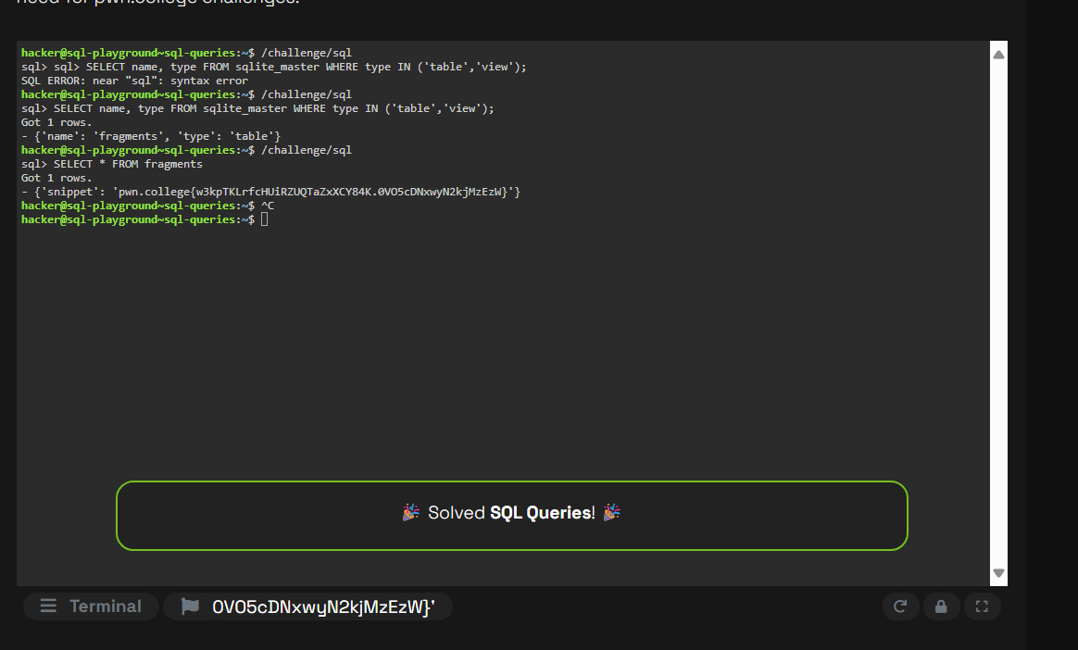
2. Filtering SQL
   1. 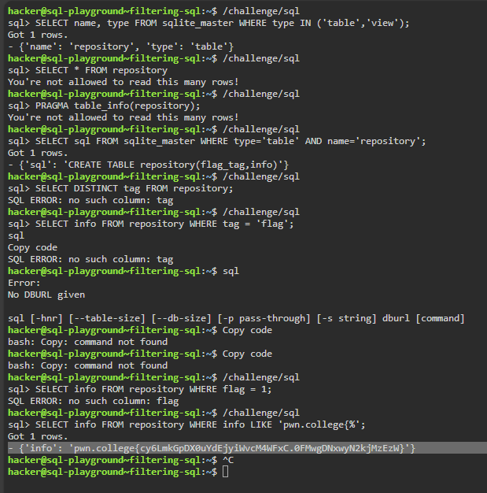
3. Choosing Columns
   1. 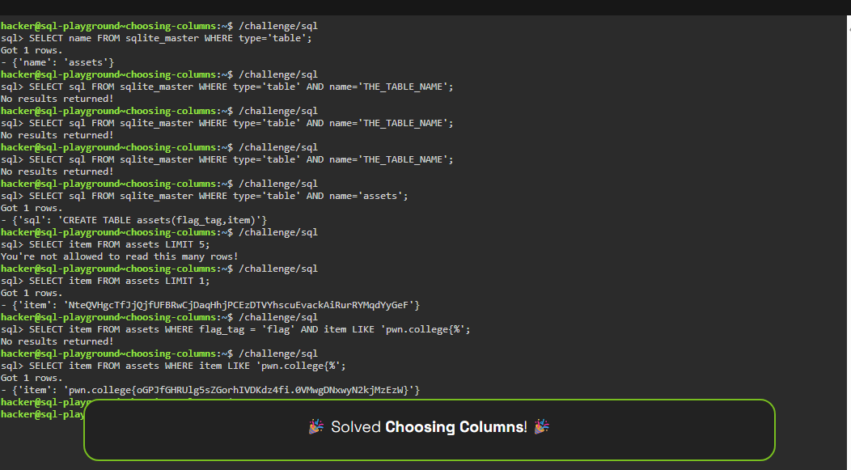
4. Exclusionary Filtering
   1. 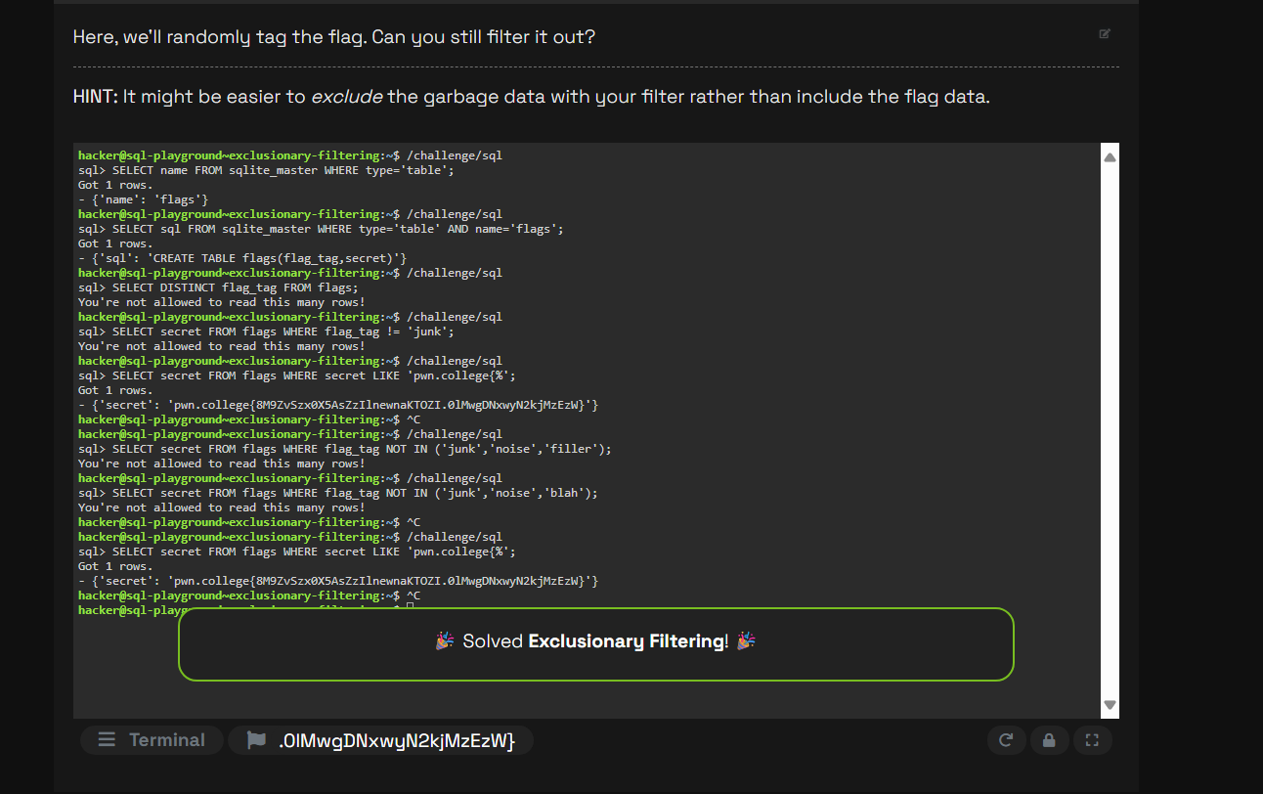

**Lab 7- 9/17/25**

1. Filtering Strings
   1. 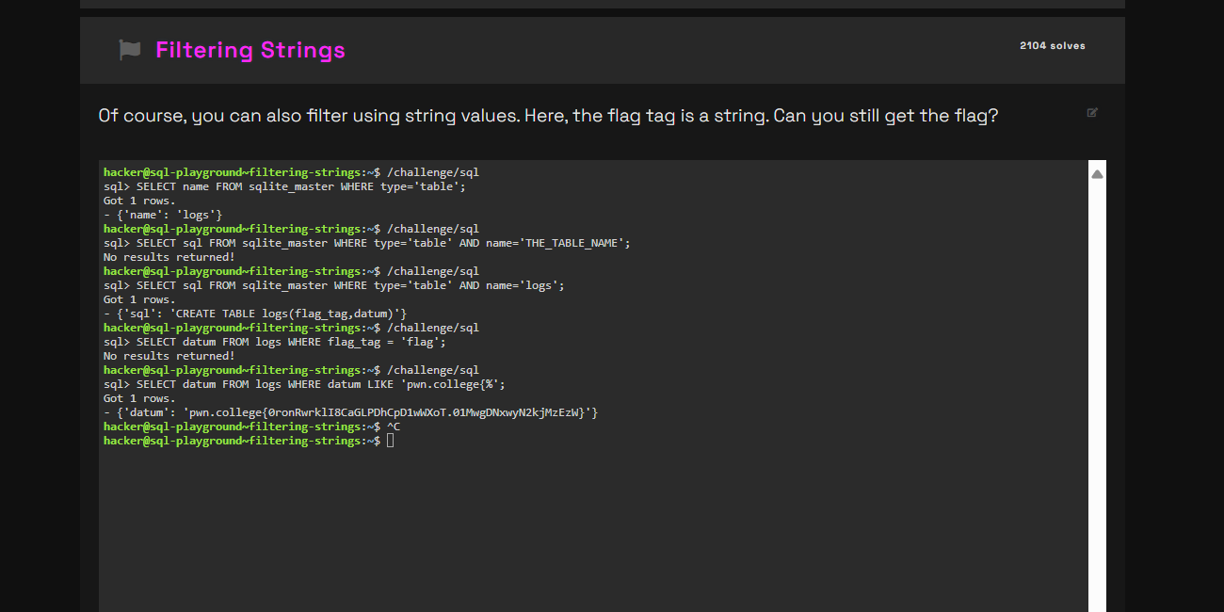
2. Filtering on Expressions
   1. 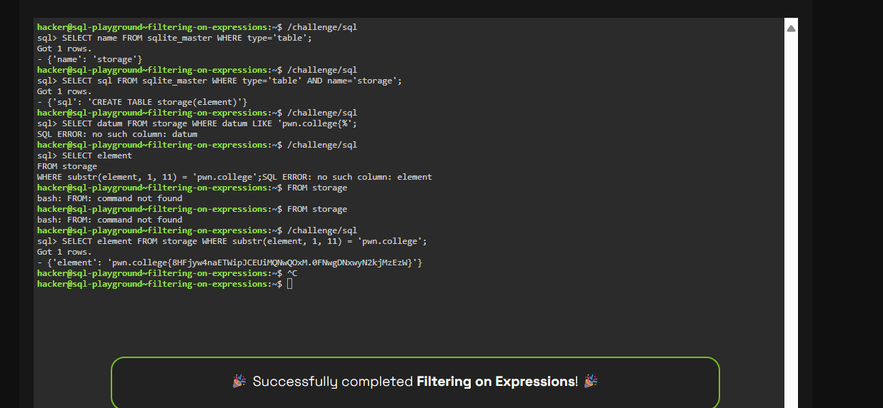
3. SELECTING Expressions
   1. 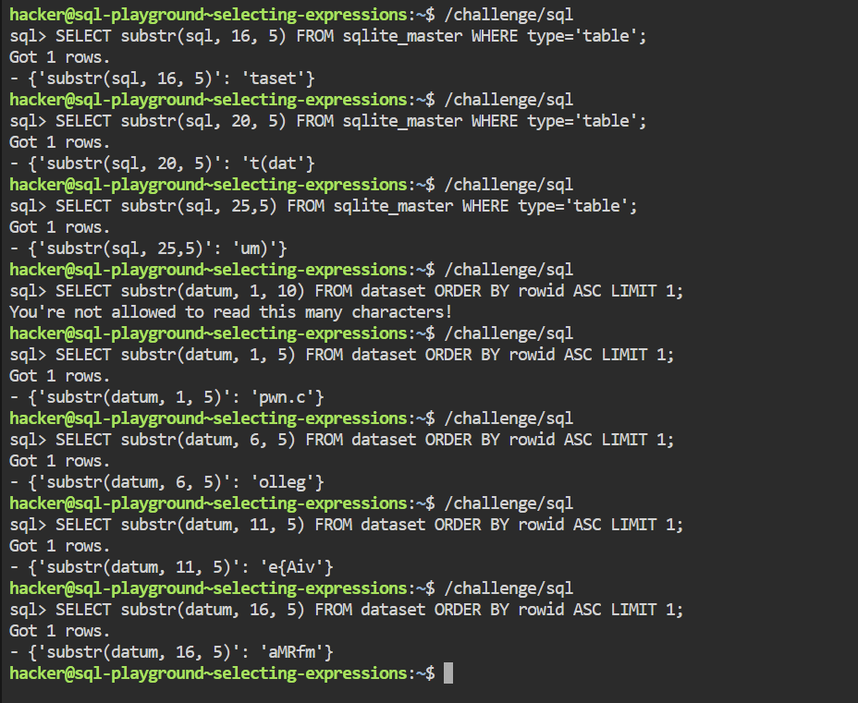

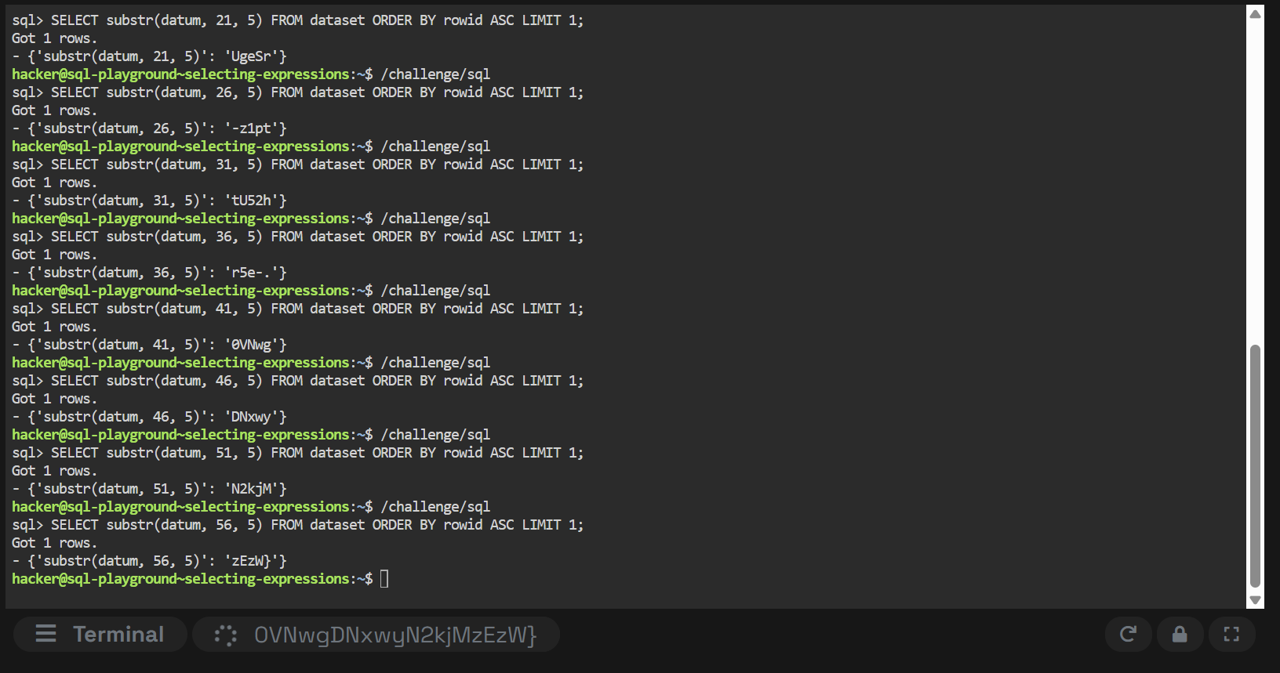

1. COmposite conditions
   1. 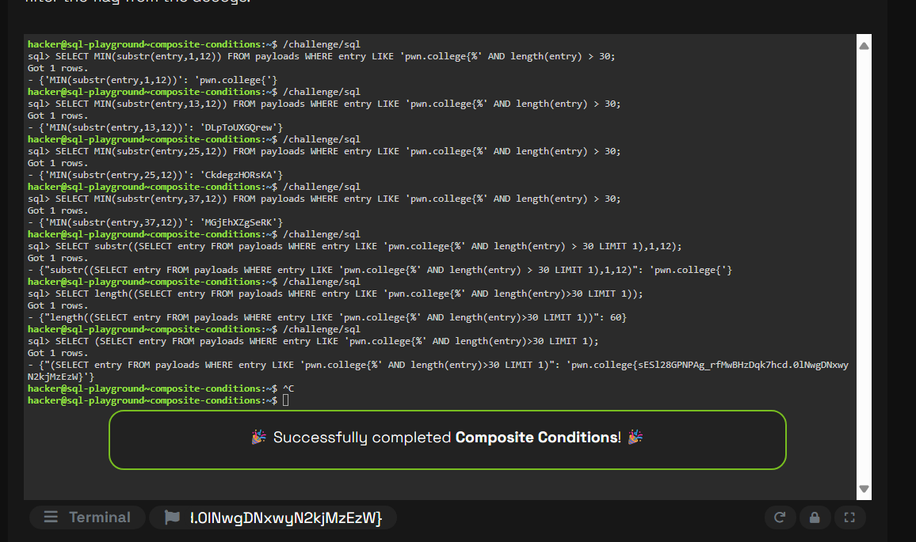
2. Reaching your limits
   1. 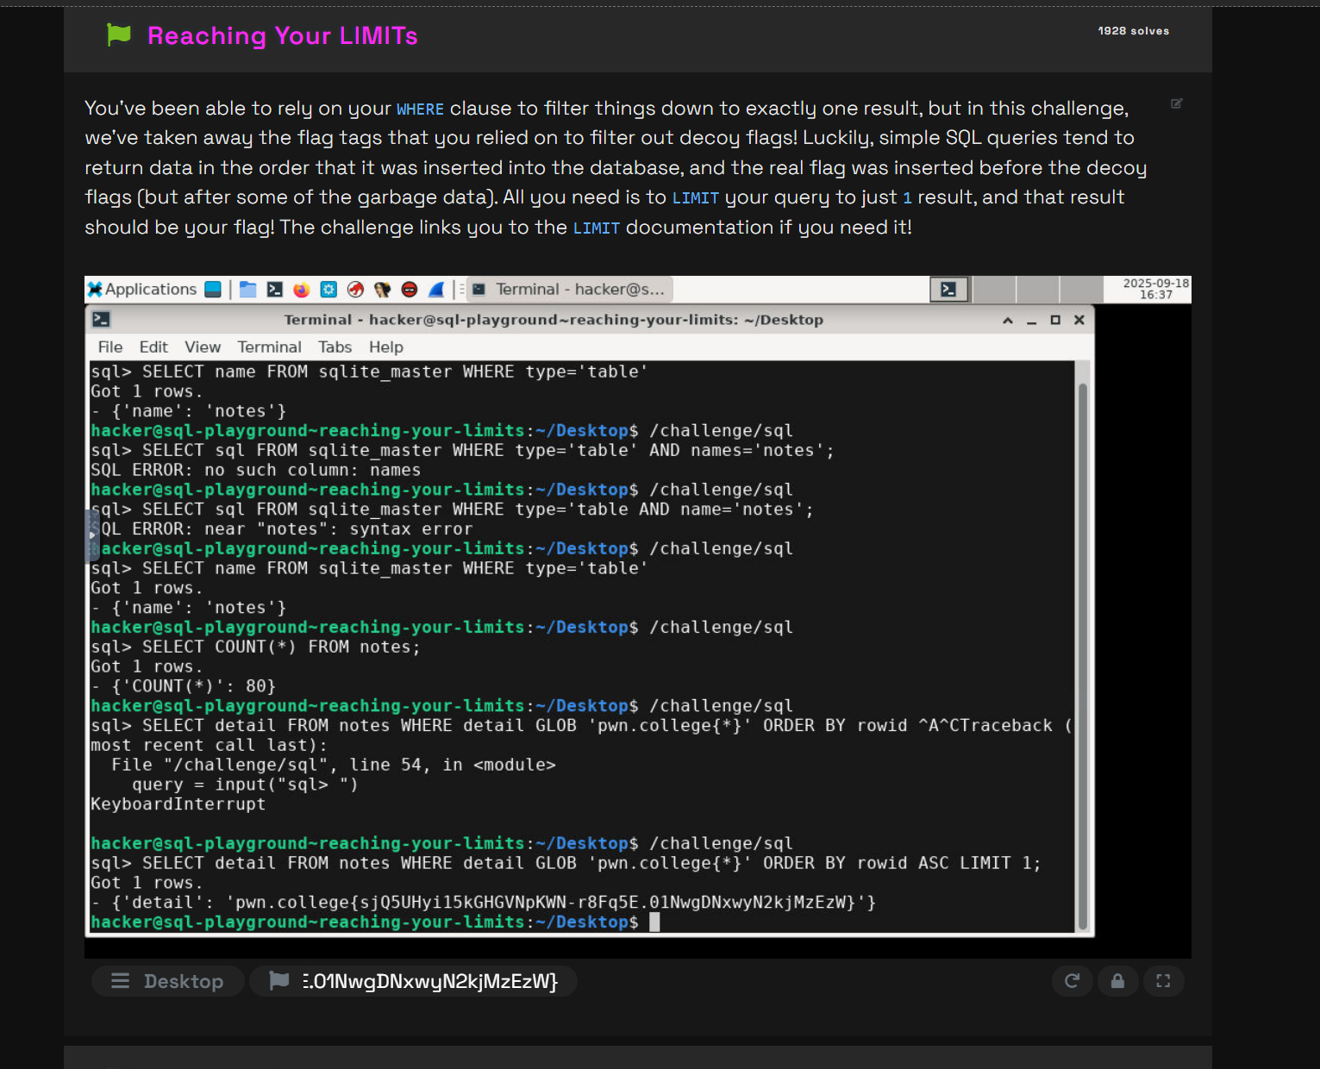
3. Querying Metadata
   1. 